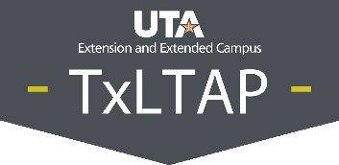

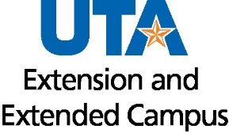

# **Attachment E**

# **Performance Evaluation Phrases**

This attachment provides examples of phrases that will provide you with the language you may use as is or modify as you need when writing the narrative portion when conducting Employee Evaluations (closing out a plan). Whether the wording needs to reflect a positive attribute, a negative or needs an improvement attribute, these phrases can be used. Some of these phrases are close to one another in their wording. This is done to provide as many examples as possible and to give you more choices.

The following suggested evaluation phrases have been derived from several sources, along with some developed by the author of this manual. The sources used for the phrases are listed if you wish to search for other phrases you may wish to use.

[2000+ Performance Review Phrases: The Complete List (Performance Feedback Examples) (status.net)](https://status.net/articles/performance-review-phrases-examples/)

[23 Performance Evaluation Phrases To Use in a Review | Indeed.com](https://www.indeed.com/career-advice/career-development/performance-evaluation-phrases#:~:text=In%20regards%20to%20the%20way%20your%20team%20members,quite%20frequently%207%20Unwilling%20to%20work%20overtime%20hours)

[100 Useful Performance Review Example Phrases (myhubintranet.com)](https://www.myhubintranet.com/performance-review-example-phrases/)

[150 Performance Review Examples and Phrases for Feedback (empuls.io)](https://blog.empuls.io/performance-review-examples/)

[Performance Appraisal Phrases: 200 Helpful Phrases For Employee Performance Reviews - Sling (getsling.com)](https://getsling.com/blog/performance-appraisal-phrases/)

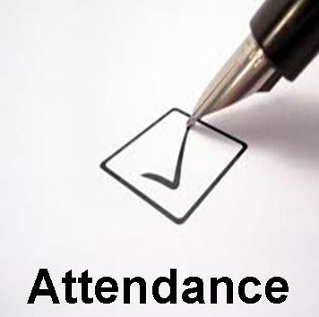**Attendance**

*Positive attributes.*

* (Name of employee) excels in reporting on time, rarely leaves early, and

adheres to all established break times.

* (Name of employee) on the rare occasion that you have missed work,

you have called in to provide notice and ensure your responsibilities were

covered.

* (Name of employee) always arrives on time each workday.

Image Source: blogspot.com

* (Name of employee) is always available to assist with special projects

or emergencies outside their regular work schedule.

* (Name of employee) has attained a perfect attendance record (zero missed days) over a (one) (two) (three)-year period.
* (Name of employee) routinely exceeds expectations in arriving on time for work, including meetings and conferences.
* (Name of employee) has good attendance and doesn’t violate the standard attendance policy.
* (Name of employee) begins each day fully refreshed and prepared for challenges.
* (Name of employee) has an excellent attendance record of (xx)% for the year.
* (Name of employee) performance is always reliable and follows the work schedule well.
* (Name of employee) manages their schedule well by completing all tasks assigned for the week.
* (Name of employee) sets a standard by their perfect attendance.
* (Name of employee) is the ideal employee who arrives to work, leaves on time, and only takes breaks per their schedule.
* (Name of employee) arrives at work every day fully prepared to tackle their responsibilities.
* (Name of employee) is reliable, and there are no concerns with their attendance.
* (Name of employee) is punctual for work and meetings.
* (Name of employee) always arrives to work prepared.

*Negative or improvement needed attributes.*

* (Name of employee) has frequently returned late from lunch breaks and is often late reporting to work.
* (Name of employee) has demonstrated a pattern of tardiness by consistently arriving 15 minutes or later for work.
* (Name of employee) has not met the established standards for attendance.
* (Name of employee) has consistently arrived late for work, which is unacceptable.
* (Name of employee) habitually exceeds the maximum number of leave days allowable.
* (Name of employee) has not met the attendance objectives set in their Performance Improvement Plan.
* (Name of employee) has been warned to show more respect to others by arriving early or on time for meetings.
* (Name of employee) needs to improve their attitude towards timely reporting to work.
* (Name of employee) needs to improve their attendance record and review the attendance policy.
* (Name of employee) would benefit from starting each day by reviewing the daily schedule and expectations.
* (Name of employee) should practice arriving on time for meetings and conferences.
* (Name of employee) has not met the required punctuality and attendance standards.
* (Name of employee) follows the appropriate schedule but often returns late from off-site activities, negatively impacting coworkers.
* (Name of employee) does not meet the attendance standards for punctuality.
* (Name of employee) is often late for work and does not follow the attendance policy.

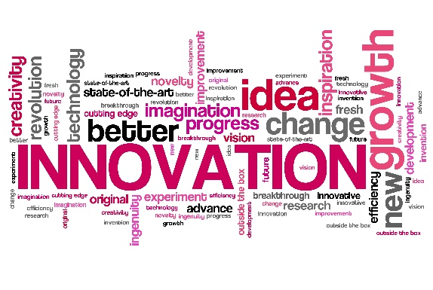**Innovation and Creativity**

*Positive attributes.*

* (Name of employee) imagination is like no one I’ve ever

worked with. They find new solutions to some of our

most complex problems.

* (Name of employee) is very detail-oriented, and it’s

appreciated how you positively share your knowledge with

others.

Image Source: eit.europa.eu

* (Name of employee) creates an exciting team atmosphere

with coworkers.

* (Name of employee) applies creative thinking to help implement the organization’s vision.
* (Name of employee) continuously suggests new ideas in meetings and on projects.
* (Name of employee) shows initiative in developing new thinking methods to improve projects or performance.
* (Name of employee) offers creative solutions to project challenges.
* (Name of employee) demonstrates the ability to develop creative solutions to solve problems.
* (Name of employee) is skillful at facing challenging problems and providing solutions.
* (Name of employee) possesses insightful perspectives on issues, which is valuable when the team needs to solve critical problems.
* (Name of employee) is an expert at turning innovative ideas into solutions.
* (Name of employee) demonstrates the ability to challenge common problems by creating new and innovative solutions.
* (Name of employee) successfully overcomes new challenges routinely.
* (Name of employee) constantly seeks to improve processes and increase efficiency.
* (Name of employee) sets realistic goals and tracks their improvement.
* (Name of employee) takes creative ideas and turns them into practical solutions to solve everyday issues.
* (Name of employee) encourages creative team collaboration by inviting diverse perspectives.
* (Name of employee) resolved long-standing (name of the problem) with the creative workaround solution (name of the solution).
* (Name of employee) regularly develops innovative solutions when facing obstacles and challenges.
* (Name of employee) understands when to take creative risks and when to stick with more conventional solutions.
* (Name of employee) takes the initiative and is proactive in gathering information and assembling the tools or team members required to complete a project on time and within budget.
* (Name of employee) doesn’t wait for instructions by showing initiative to find new tasks for themself.
* (Name of employee) is a goal-oriented person by setting their priorities to accomplish the job.
* (Name of employee) is a very creative person skilled in finding the best ways to get a job done.
* (Name of employee) has a high sense of responsibility for his job by trying to perfect their performance without prompting.

*Negative or improvement needed attributes.*

* (Name of employee) solutions to problems are often rigid and come off as outdated or not aligned with current best practices.
* (Name of employee) should consider encouraging your team to think creatively about solutions due to the ever-changing work environment
* (Name of employee) is always unconcerned with the creative and innovative side of the team.
* (Name of employee) does not encourage creative solutions from team members.
* (Name of employee) is unwilling to work on problems outside their skill set.
* (Name of employee) shows a lack of interest in using creative or innovative ideas.
* (Name of employee) struggles to overcome new challenges and effectively find solutions to new issues.
* (Name of employee) tends to focus more on what can’t be done than what can be done.
* (Name of employee) would benefit by setting goals and tracking progress.
* (Name of employee) could improve in areas where creative solutions are needed.
* (Name of employee) could benefit from thinking outside the box.
* (Name of employee) could offer alternative solutions to challenges.
* (Name of employee) could show initiative in proposing new projects.
* (Name of employee) struggles to adjust their work when faced with changing needs of the organization.
* (Name of employee) demonstrates resistance to embracing new approaches or ideas.
* (Name of employee) is unwilling to explore the creative ideas of peers.
* (Name of employee) experience and knowledge doesn’t reflect that listed in their application.
* (Name of employee) must be closely supervised to perform their work.
* (Name of employee) won’t improve if they continue to neglect the opportunities in front of them.
* (Name of employee) does not seem adaptable by being unable to perform consistently under pressure.
* (Name of employee) typically thinks inside the box and is afraid to risk doing anything in a new way.
* (Name of employee) is indecisive, unable to make quick decisions, take action or commit themself to a project’s completion.
* (Name of employee) doesn’t apply themself as much as they could given their experience and knowledge.
* (Name of employee) doesn’t want to learn new techniques or skills.
* (Name of employee) has trouble doing tasks without help or supervision.
* (Name of employee) doesn’t seek out opportunities to learn and grow in their role.
* (Name of employee) fails to think out of the box and prefers to do things as they have always been.
* (Name of employee) always has issues when dealing with tasks alone.
* (Name of employee) often works unprofessionally and avoids doing anything innovatively.

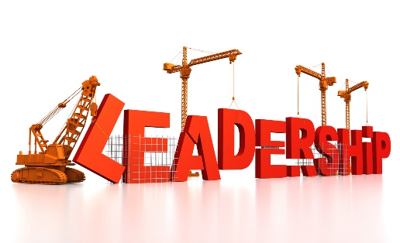**Leadership**

*Positive attributes.*

* (Name of employee) is fair and treats everyone on their team

and in the office equally.

* (Name of employee) leads by example. Your approach to

Image Source: edtechinnovations.org

embracing change and adapting to changing work situations

encourages your team to do the same.

* (Name of employee) team consistently meets its goals while often exceeding expectations.
* (Name of employee) is always ready to assist a coworker.
* (Name of employee) encourages their team members to suggest new ideas.
* (Name of employee) has a good understanding of team members’ strengths and leverages those strengths for maximum efficiency.
* (Name of employee) helps their team to stay focused on goals and objectives.
* (Name of employee) observes schedules and plans and encourages the team to do the same.
* (Name of employee) always shows appreciation to team members for a well-done job.
* (Name of employee) always encourages their team members to work hard.
* (Name of employee) always promotes a learning culture among coworkers and team members.
* (Name of employee) listens actively and promptly responds to every complaint or suggestion from the public, coworkers, and team members.
* (Name of employee) is an excellent example of a leader for others to follow.
* (Name of employee) led the (name of the project) that came in under budget, ahead of schedule, and with a high quality of work.
* (Name of employee) understands team members’ strengths and is an effective motivator.
* (Name of employee) effectively delegates tasks to other team members with clear responsibilities and expectations.
* (Name of employee) appropriately distributes resources depending on the priority of assignments.
* (Name of employee) is ready to share information and knowledge for the common development of all staff.
* (Name of employee) is very helpful when mentoring entry-level staff to get used to their jobs.
* (Name of employee) creates a culture of dialogue.
* (Name of employee) recognizes staff for a job well done.
* (Name of employee) allocates tasks appropriately based on the prior assignments.
* (Name of employee) understands people and how to motivate them to get the job done.
* (Name of employee) provides constant coaching and guidance to employees.
* (Name of employee) is very good at managing their team to perform their tasks excellently.
* (Name of employee) is a good manager and leads the team to perform their assignments well.
* (Name of employee) designs action plans and deadlines for each subordinate to accomplish their tasks.
* (Name of employee) is very professional with his employees and manages them well.
* (Name of employee) has received good feedback from the team and managers.
* (Name of employee) is adept at managing difficult employees and turning their energies towards higher performance.
* (Name of employee) is an excellent manager who can lead staff to meet expectations.

*Negative or improvement needed attributes.*

* (Name of employee) tends to be biased in some situations, which causes employees to fear asking for your help.
* (Name of employee) has the makings of a strong leader, but I want to encourage you to speak with confidence and authority in team meetings to gain the respect and attention you deserve from your team.
* (Name of employee) needs to improve your ability to speak respectfully with team members.
* (Name of employee) has been counseled to help and encourage their team members to work efficiently to meet their goals.
* (Name of employee) must learn how to treat coworkers equally.
* (Name of employee) wastes too much time providing a solution when a quick one is required.
* (Name of employee) has difficulty delegating responsibilities to team members.
* (Name of employee) does not show appreciation for their team members for a well-done job.
* (Name of employee) has difficulty keeping certain information confidential.
* (Name of employee) confuses employees through different directions and guidance.
* (Name of employee) rarely shows appreciation for good performance.
* (Name of employee) fails to explain procedures to subordinates clearly.
* (Name of employee) despite being a good supervisor, does not know how to lead staff to achieve a higher level of performance.
* (Name of employee) fails to resolve conflict among subordinates.
* (Name of employee) fails to resolve problems until they become conflicts.
* (Name of employee) fails to meet schedules.
* (Name of employee) does not cope very well with managing employees.
* (Name of employee) does not understand how to set team goals and manage the team to achieve them.
* (Name of employee) is an adequate task manager but falls short when setting a vision.



**Communication and Interpersonal Skills**

*Positive attributes.*

* (Name of employee) excels at building great relationships, which is

reflected by how highly your team and others speak of you.

* (Name of employee) practices active listening skills by waiting until

others have finished speaking and then speaks.

* (Name of employee) provides clear directions, expectations, and

Image Source: sunnyraj.com

feedback to your team.

* (Name of employee) possesses and uses highly effective verbal and written communication skills.
* (Name of employee) possesses and uses the skills to communicate the complex requirements of tasks and projects to their team members.
* (Name of employee) has built good work relationships through open and friendly communication.
* (Name of employee) collaborates well with colleagues and superiors to ensure effective working relationships.
* (Name of employee) effectively communicates with peers, supervisors, contractors, and the public.
* (Name of employee) respectfully communicates well with coworkers and adapts easily to many situations.
* (Name of employee) clearly communicates ideas and thoughts in team meetings and conferences.
* (Name of employee) is a constructive communicator capable of discussing complex issues effectively and to the point.
* (Name of employee) does a great job communicating issues and practicing active listening when given directions.
* (Name of employee) works effectively within a team environment to achieve specific tasks or projects.
* (Name of employee) develops constructive working relationships with internal and external stakeholders.
* (Name of employee) is an effective team player, as demonstrated by their willingness to help and contribute as required.
* (Name of employee) offers constructive and respectful feedback to peers and team members.
* (Name of employee) often asks for immediate feedback to clarify and ensure understanding.
* (Name of employee) regularly asks well-prepared or thoughtful questions.
* (Name of employee) quickly asks follow-up questions pinpointing potential misunderstandings.
* (Name of employee) exhibits a sense of humor and brings levity to the workplace in an appropriate manner.
* (Name of employee) is comfortable saying, “I’m not sure. Can I get back to you?”
* (Name of employee) asks others for their opinions and makes coworkers feel comfortable contributing their opinions.
* (Name of employee) promotes cooperation, communication, and collaboration by sharing their knowledge and inviting others to do the same.
* (Name of employee) communicates expectations, objectives, and critical results to team members and direct reports.
* (Name of employee) works effectively within a team environment to achieve specific tasks or projects such as (name the task or project).
* (Name of employee) develops constructive working relationships with internal and external stakeholders.
* (Name of employee) displays the ability to communicate at all levels – up, down, and across the organization.
* (Name of employee) verbal and written communication skills are highly effective.
* (Name of employee) is a friendly communicator and has built a rapport with every department in the organization.
* (Name of employee) positive attitude and willingness to listen are highly appreciated by coworkers.
* (Name of employee) regularly gives constructive feedback.
* (Name of employee) makes new employees feel welcome.
* (Name of employee) provides accurate and timely written and oral information.
* (Name of employee) actively listens to others.
* (Name of employee) involves others in problem-solving.
* (Name of employee) provides clear instructions and expectations.
* (Name of employee) accepts criticism, is open to new ideas, and handles conflict constructively and diplomatically.

*Negative or improvement needed attributes.*

* (Name of employee) should try explaining their point of view using less technical terms when speaking with their peers and members of other teams.
* (Name of employee) must practice active listening skills by waiting until others have finished speaking before asking questions and offering your opinion.
* (Name of employee) your lack of or sporadic communication causes many misunderstandings among your team members resulting in confusion and lost time.
* (Name of employee) lacks the required communication skills to effectively lead a team and relate with their team members and others.
* (Name of employee) finds it difficult to communicate ideas and messages to their team members and others.
* (Name of employee) must develop the skills to communicate effectively with team members.
* (Name of employee) leads their team well but needs to improve their attitude with receiving feedback from their team.
* (Name of employee) needs to be encouraged to work cooperatively and respectfully with team members and others.
* (Name of employee) could improve with fully listening to instructions before asking questions.
* (Name of employee) could improve communicating progress updates to supervisors.
* (Name of employee) could improve by offering constructive feedback to team members on new projects.
* (Name of employee) could benefit by learning stronger team-building skills.
* (Name of employee) could strengthen working relationships with peers and vendors.
* (Name of employee) could offer to help other colleagues with projects.
* (Name of employee) can sometimes be too blunt in their feedback.
* (Name of employee) tends to ramble on, making it difficult for them to communicate a clear message.
* (Name of employee) exhibits difficulty breaking down complex issues into manageable parts in their communication.
* (Name of employee) needs to work on their written communication skills by doing the following (provide example).
* (Name of employee) has room for developing listening skills, particularly in team meetings when different viewpoints are expressed.
* (Name of employee) fails to communicate with team members effectively.
* (Name of employee) is not adept at documenting verbal communications.
* (Name of employee) should communicate project status updates more frequently.
* (Name of employee) does not promptly return calls, texts, or emails.
* (Name of employee) needs to work on listening to others.
* (Name of employee) works well with members of their team yet has an “us” against “them” mentality when it comes to others within the organization.

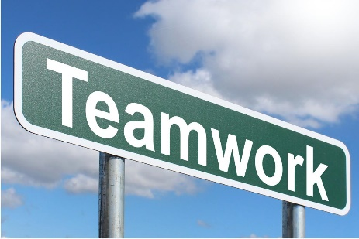

**Teamwork, Collaboration, and Support**

*Positive attributes*

* (Name of employee) leads their team well and assigns proper

duties to them.

* (Name of employee) has developed a highly engaged team that

works well together to start and complete projects on time.

Image Source: picserver.org

* (Name of employee) offers assistance to others even when they

are outside their direct report structure.

* (Name of employee) is always ready to offer the proper assistance to team members or others who are having difficulty with their job duties.
* (Name of employee) has built and maintains good relationships with all team members.
* (Name of employee) acts as a go-to member for new employees by offering feedback, guidance, and sharing ideas to help them succeed.
* (Name of employee) team has succeeded because of your ability to build strong relationships by asking for and incorporating suggestions and ideas from them and others.
* (Name of employee) always displays a cooperative spirit by performing extra tasks to contribute to a project.
* (Name of employee) promotes cooperation to ensure all team members work together to meet deadlines.
* (Name of employee) is always willing to coordinate tasks with colleagues.
* (Name of employee) always offers to help with tasks outside their role.
* (Name of employee) continuously works to maintain and develop professional relationships.
* (Name of employee) elevates their team’s performance and productivity by [include one to two specific examples].
* (Name of employee) promotes cooperation with their team and encourages participation from individual members.
* (Name of employee) builds effective teams by helping team members play to their strengths
* (Name of employee) drives creativity across the team by seeking different perspectives and taking reasonable risks.
* (Name of employee) proactively shares knowledge, skills, and expertise with other team members.
* (Name of employee) can effectively collaborate with team and project members to complete tasks.
* (Name of employee) shows a willingness to share ideas, best practice techniques, and new ways of doing things.
* (Name of employee) strengths are the ability to design achievable goals.
* (Name of employee) is effective at goal-setting and challenging themself and others.
* (Name of employee) clearly communicates goals and objectives to coworkers.
* (Name of employee) takes responsibility for the performance of staff members.
* (Name of employee) defines clear goals and expects good performance from the team.
* (Name of employee) knows how to keep staff focused on a plan.
* (Name of employee) knows to assign suitable duties to each staff member.
* (Name of employee) gives frequent feedback to the team members. Coaching is provided for them to perform as required.
* (Name of employee) constantly strives to be the best possible.
* (Name of employee) sets concrete and measurable goals.
* (Name of employee) proactively shares progress towards goals.
* (Name of employee) usually shares his knowledge with staff to help them perform their duties better.
* (Name of employee) takes responsibility for the team’s work and goals.
* (Name of employee) assigns the correct duty to the right staff and instructs them on how to perform their assignments well.
* (Name of employee) ensures the staff understands their job responsibilities. The team is held accountable for their individual responsibilities.
* (Name of employee) clearly communicates objectives and what is expected from the team.
* (Name of employee) consistently shares feedback with staff regarding their progress.
* (Name of employee) sets clear and measurable performance expectations.
* (Name of employee) demonstrates a high level of team spirit.
* (Name of employee) respects every team member.
* (Name of employee) works well with others.
* (Name of employee) always helps out to achieve the goals of the group.
* (Name of employee) is very willing to help fellow teammates.
* (Name of employee) is a good team member.

*Negative or improvement needed attributes.*

* (Name of employee) has shown a pattern of interrupting others when they are speaking in meetings. While this may be unintentional, it can be helpful to show respect for others by waiting until they have finished speaking before adding to the conversation.
* (Name of employee) inability to work well with others has caused your team to fall behind.
* (Name of employee) needs support, coaching, and assistance to work cooperatively with others.
* (Name of employee) is unwilling to help coworkers with their tasks even when it is solicited.
* (Name of employee) is an expert, but they could offer more professional advice to others to help them learn from your expertise.
* (Name of employee) needs to learn the skills of completing tasks with the cooperation of others.
* (Name of employee) needs to inspire others to give their best on the job.
* (Name of employee) should work towards improving their teamwork skills.
* (Name of employee) should work on refining their collaboration skills.
* (Name of employee) could offer to help colleagues on a deadline.
* (Name of employee) should offer to train new employees when a need arises for guidance.
* (Name of employee) should work on developing and maintaining professional relationships.
* (Name of employee) is unwilling to commit their staff’s resources to other departments when asked.
* (Name of employee) fails to provide guidance or hands-on support to struggling team members.
* (Name of employee) discourages coworkers from volunteering ideas by interrupting others in team meetings.
* (Name of employee) responds aggressively when their authority is challenged.
* (Name of employee) tends not to contribute to team or project meetings and doesn’t always participate in team activities or bonding exercises.
* (Name of employee) tends to work in isolation.
* (Name of employee) can be overly negative or critical in contributing to team or project meetings.
* (Name of employee) fails to see the bigger picture beyond the team and department.
* (Name of employee) finds it difficult to delegate to team members, preferring to maintain control.
* (Name of employee) needs to work on making team members feel comfortable voicing concerns or bringing up issues.
* (Name of employee) does not encourage or reward the ideas and solutions offered by team members.
* (Name of employee) is ineffective at pursuing goals.
* (Name of employee) is easily distracted at work. Often he fails to focus on goals, resulting in failure.
* (Name of employee) pushes responsibility for deadlines and objectives to employees instead of accepting them as the supervisor.
* (Name of employee) is ineffective at setting achievable goals.
* (Name of employee) is inconsistent in defining goals and objectives.
* (Name of employee) assigns tasks to employees without providing any information or feedback to keep them on track.
* (Name of employee) sets performance goals that are out of touch with reality.
* (Name of employee) leaves peers struggling to understand the status of a project.
* (Name of employee) refuses to delegate to others.
* (Name of employee) is unwilling to accept responsibility for missed goals.
* (Name of employee) is easily distracted.
* (Name of employee) does not achieve goals or objectives because he does not focus on personal performance.
* (Name of employee) will shift responsibility onto others for unaccomplished deadlines or goals.
* (Name of employee) sometimes does not reach set goals.
* (Name of employee) rarely achieves goals due to the inability to assign the proper duties to the right person.
* (Name of employee) should strive to aim higher when setting goals.
* (Name of employee) would benefit from reigning in goals and vision to something more achievable.
* (Name of employee) doesn’t have a good relationship with team members, often refusing to accept their opinion.
* (Name of employee) is not consistent in supporting teammates.
* (Name of employee) does not understand how to share tasks with others.
* (Name of employee) is more suitable to an individual-focused environment than a group-work environment.
* (Name of employee) does not know how to cooperate with colleagues on the team to achieve targets.



**Time Management**

*Positive attributes*

* (Name of employee) has consistently delivered their work ahead of

schedule and never forgets any details.

* One of (name of employee) greatest strengths is your ability to manage

multiple responsibilities.

* This year, (Name of employee) has demonstrated their ability to take on

new projects while meeting daily goals.

* (Name of employee) ensures their team keeps to project schedules.
* (Name of employee) shows strong time-management and

Image Source: blog.socrato.com

organizational skills.

* (Name of employee) regularly meets all required team and project deadlines.
* (Name of employee) comes prepared for meetings with an agenda and supporting papers. Takes the time to digest the information and comes to meetings ready to contribute.
* (Name of employee) performs tasks wholeheartedly and promptly accomplishes them.
* (Name of employee) shows the ability to manage and accomplish various tasks on time.
* (Name of employee) uses time effectively to perform the big and small duties which must be done every week.
* (Name of employee) divides time logically to achieve goals.

*Negative or improvement needed attributes.*

* To make the most of scheduled meetings with others, (name of employee) needs to make it a practice to prepare an agenda to ensure you stay on track and take full advantage of your time with peers and supervisors.
* (Name of employee) I’ve observed that there are times when you lack a sense of urgency. As a result, you’ve failed to meet deadlines on time.
* (Name of employee) could improve in communicating issues in assignments before missing deadlines.
* (Name of employee) should work towards improving their time management skills.
* (Name of employee) needs to improve their time management skills to deliver projects and tasks on time consistently. If not, then the reasons are effectively communicated at the earliest opportunity.
* (Name of employee) needs to pay more attention to time management of meetings and meeting preparedness.
* (Name of employee) does not know how to manage time and cannot satisfy deadlines of projects.
* (Name of employee) should learn how to manage time more effectively.
* (Name of employee) should make a weekly work plan. Too much time is spent performing assignments without a proper plan.
* (Name of employee) cannot complete tasks due to poor time management.
* (Name of employee) takes too much time to perform tasks. It is advised to make a concrete plan for every week.

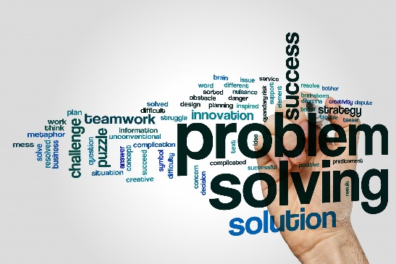

**Problem-Solving**

*Positive attributes.*

* (Name of employee) always gathers all the information and

facts to make a decision that benefits the entire team.

* (Name of employee) has shown a practical approach to solving

problems by breaking down large concepts into smaller,

more manageable tasks.

Image Source: sanctustraining.co.uk

* (Name of employee) takes obstacles as problems to solve.

(Name of employee) has a knack for working with others to find solutions to problems.

* (Name of employee) displays the capability to solve complex problems independently.
* (Name of employee) breaks down a problem before analyzing it more thoroughly.
* (Name of employee) collaborates well with others to find solutions to project challenges.
* (Name of employee) offers multiple solutions to complex problems.
* (Name of employee) quickly identifies more efficient solutions.
* (Name of employee) identifies potential roadblocks or bottlenecks to avoid delays.
* (Name of employee) finds repeatable solutions to complex problems.
* (Name of employee) is creative and innovative in finding solutions to issues.
* (Name of employee) can identify problems early on and proactively finds solutions.
* (Name of employee) always addresses the underlying causes of problems rather than just the symptoms.
* (Name of employee) consistently encourages team members to find their solutions to problems.
* (Name of employee) is skilled at analyzing situations and finding solutions.
* (Name of employee) continually clearly defines a problem and seeks alternative solutions.
* (Name of employee) is decisive under challenging situations.
* (Name of employee) can make sound fact-based judgments.
* (Name of employee) continually analyzes an issue carefully and then looks for different ways to resolve that issue.

*Negative or improvement needed attributes.*

* (Name of employee) has the opportunity to strengthen your problem-solving skills by considering potential solutions before taking action on one.
* (Name of employee) lacks problem-solving skills and often disrupts your team members by expecting them to help you complete simple tasks.
* (Name of employee) could improve your brainstorming solutions to challenges.
* (Name of employee) could benefit from thinking of creative solutions to challenges.
* (Name of employee) could strengthen your collaboration skills when working to solve challenges.
* (Name of employee) could ask for assistance with problem-solving challenges.
* (Name of employee) often struggles to see the patterns in recurring issues.
* (Name of employee) linearly approaches problems, focusing on only one component at a time.
* (Name of employee) has difficulty identifying the root cause of problems.
* (Name of employee) tends to make excuses or blame others when things don’t go well.
* (Name of employee) becomes upset and panicked in the face of problems and issues.
* (Name of employee) applies overly complex and impractical problem-solving approaches.
* (Name of employee) is often paralyzed and confused when facing tight deadlines to make decisions.
* (Name of employee) struggles to work out a solution to any difficult problem.
* (Name of employee) is uncomfortable when faced with any awkward problem.
* (Name of employee) easily loses focus when facing a complex situation.

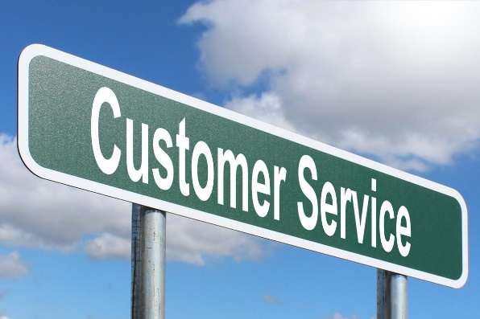**Resident/Client/Customer Interactions and Service**

*Positive attributes.*

* (Name of employee) has shown a solid commitment to

serving residents by returning calls within two hours of the

same day.

* (Name of employee) residents appreciate your eagerness

to help from the numerous compliments we have received.

* (Name of employee) is outstanding at customer service.
* (Name of employee) relates easily with all members of the

public.

Image Source: picserver.org

* (Name of employee) is always ready to help coworkers and

customers regardless of the issue.

* (Name of employee) can handle difficult service circumstances effectively.
* (Name of employee) is very competent at making a difference in customer service.
* (Name of employee) is always calm and sensible when facing difficult or angry residents/clients.
* (Name of employee) displays the ability to work effectively with clients.
* (Name of employee) is pleasant and shows empathy when interacting with customers.
* (Name of employee) can handle demanding customers and situations.
* (Name of employee) constantly strives to improve the customer experience.
* (Name of employee) shows initiative when problem-solving customer problems.
* (Name of employee) can find the right approach with any client, even the most critical one.
* (Name of employee) is always polite and friendly with customers and never interrupts them during a conversation.
* (Name of employee) consistently exceeds job requirements to satisfy customers.
* (Name of employee) deals with demanding customers with grace.
* (Name of employee) provides consistent, quality customer service.
* (Name of employee) follows up with customers promptly.
* (Name of employee) makes an extra effort to keep customers accurately informed.

*Negative or improvement needed attributes.*

* (Name of employee) has been counseled to listen effectively to citizens’ complaints.
* (Name of employee) finds it challenging dealing with difficult citizens.
* (Name of employee) must learn to resolve citizen complaints effectively.
* (Name of employee) must avoid passing the complaining citizens on to coworkers.
* (Name of employee) must learn how to handle clients’ requests efficiently.
* (Name of employee) needs to improve their skill in handling face-to-face complaints of citizens.
* (Name of employee) needs to develop a better rapport and more responsive relationship with customers.
* (Name of employee) could be more proactive in dealing with customer concerns.
* (Name of employee) can deal with everyday customer service situations but with complex issues, is not flexible, and does not know what action to take.
* (Name of employee) can deal with customers on the phone but does not handle face-to-face customer contact very well.
* (Name of employee) does not always listen to customers well.
* (Name of employee) consistently passes challenging customer service issues to the supervisor or others instead of tackling them.
* (Name of employee) appears to become frustrated by customers who ask questions.

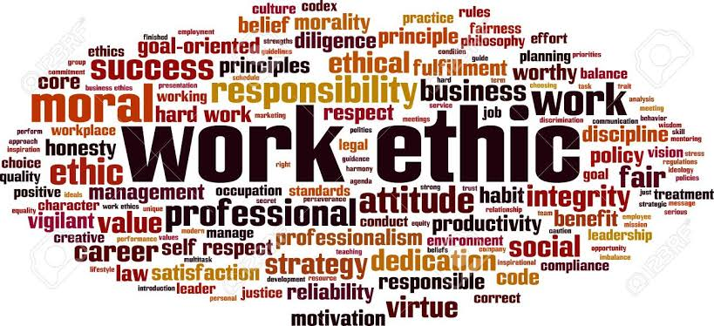

**Work Ethic**

*Positive attributes.*

* (Name of employee) is punctual and has shown

excellent work behaviors in every aspect of the job.

* (Name of employee) shows a strong work ethic by

consistently staying until all daily tasks are completed.

* (Name of employee) consistently goes above and beyond

Image Source: plopdo.com

by exceeding weekly goals.

* (Name of employee) is results-oriented. They carry out their duties until tasks are completed.
* (Name of employee) is a self-inspired employee. They strive to complete all assigned duties on schedule.
* (Name of employee) demonstrates a hunger for expertise and knowledge to perform their job well.
* (Name of employee) always performs their job duties to the best possible standards.
* (Name of employee) admits to their mistakes and errors and informs others when unable to keep a commitment.
* (Name of employee) takes responsibility for meeting deadlines.
* (Name of employee) owns their portion of project management.
* (Name of employee) displays a strong work ethic and sets an excellent example to others.
* (Name of employee) is a detail-minded person whose work is always completed with high quality.
* (Name of employee) always maintains high accuracy in their work.
* (Name of employee) maintains a good standard of work aligned with a high level of productivity.
* (Name of employee) takes on new responsibilities with minimal guidance or direction.
* (Name of employee) has a firm grasp and understanding of job responsibilities.
* (Name of employee) always maintains accuracy in their work.
* (Name of employee) never neglects any detail of any task given.
* (Name of employee) good performance level is highly appreciated. The work is high quality and accurate.

*Negative or improvement needed attributes.*

* It has been noticed that (Name of employee) could take the initiative to perform other office tasks in between helping citizens.
* (Name of employee) is often late to work and has been found wasting time rather than completing work assignments.
* (Name of employee) often comes late to work without giving tangible reasons.
* (Name of employee) does not carry out assigned duties.
* (Name of employee) takes excessive breaks, slowing down the rate of work that results in complaints from their coworkers.
* (Name of employee) often leaves the workplace before the official end of the work day.
* (Name of employee) must learn how to help others finish tasks without missing deadlines.
* (Name of employee) needs to take ownership of meeting deadlines.
* (Name of employee) needs to take responsibility for mistakes.
* (Name of employee) needs to offer solutions to project errors.
* (Name of employee) must communicate when facing project delays.
* (Name of employee) rarely achieves monthly performance targets.
* (Name of employee) produces a higher defect rate than peers.
* (Name of employee) work does not meet the required quality standards.
* (Name of employee) demonstrates a low level of knowledge of the required work procedures.
* (Name of employee) is reluctant to take on new responsibilities.
* (Name of employee) is unable to concentrate on their work.
* (Name of employee) is unaware of their job requirements.
* (Name of employee) quality of work is inconsistent and unreliable.
* (Name of employee) fails to spend sufficient time checking work before submitting it.
* (Name of employee) cannot perform their job without continual assistance.
* (Name of employee) lack of concentration results in a high level of errors.
* (Name of employee) work doesn’t pass inspection by other team members.
* (Name of employee) ignores the details of the tasks assigned.
* (Name of employee) often overlooks the key requirements given for tasks.



**Attitude**

*Positive attributes.*

* (Name of employee) had proven reliable by arriving each day

prepared to tackle their work with a positive attitude.

* (Name of employee) maintains a positive viewpoint that helps

make quality decisions in difficult situations.

* (Name of employee) positive attitude remains their most

special strength.

* (Name of employee) often shares positive thoughts and ideas

Image Source: picpedia.org

on issues, which helps others have a positive outlook on their jobs.

* (Name of employee) often encourages coworkers to give their best on the job.
* (Name of employee) has created a work environment that permits mutual trust and confidence.
* (Name of employee) maintains composure when faced with stressful or unexpected situations.
* (Name of employee) builds an atmosphere of trust within the team.
* (Name of employee) cheerful attitude makes others feel good.
* (Name of employee) has never complained about their job or colleagues.
* (Name of employee) usually focuses on the positives when dealing with problems.
* (Name of employee) is always enthusiastic and helps motivate team members.

*Negative or improvement needed attributes.*

* (Name of employee) is a good staff member who enjoys the job but whose attitude towards colleagues could be improved.
* (Name of employee) has an inconsistent attitude towards decision-making, which adversely disturbs their team's productivity.
* (Name of employee) is inconsistent in maintaining positive working relationships with some staff members.
* (Name of employee) has been counseled to improve their work attitude within 90 days, or a Performance Improvement Plan will be implemented.
* (Name of employee) language choice can sometimes be inappropriate.
* (Name of employee) level of voice is inappropriate at times.
* (Name of employee) tends to trigger problems between coworkers.
* (Name of employee) needs to control his temper and attitude when dealing with team members.
* (Name of employee) needs to learn not to react too strongly toward negative situations.
* (Name of employee) has an overly sensitive and pessimistic personality.
* (Name of employee) is easily upset by problems or difficult situations.
* (Name of employee) should try to think more positively, focus on the good and avoid being overly concerned with perceived negatives.
* (Name of employee) often has trouble with coworkers when they work on the same project.
* (Name of employee) is easily angered and argumentative with colleagues.
* (Name of employee) talks negatively about other team members.
* (Name of employee) needs to focus on the positive aspects of the job and team.

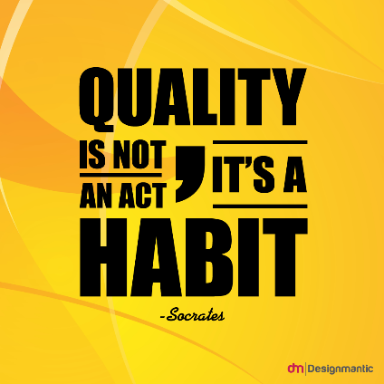

**Efficiency and Quality of Work**

*Positive attributes.*

* (Name of employee) pays attention to details on any assigned job.
* (Name of employee) ensures that work is as free of defects as much as

possible.

* (Name of employee) is a highly focused employee who pays attention

to every detail at work.

Image Source: pinterest

* (Name of employee) completes assigned tasks and meets project deadlines.
* (Name of employee) contributes to the organization’s overall performance through consistent and high-quality work.
* (Name of employee) continuously strives to improve productivity and performance targets.

*Negative or improvement needed attributes.*

* (Name of employee) rarely attains performance goals.
* (Name of employee) has a high rework rate, resulting in lost time and efficiency.
* (Name of employee) has a higher rework rate than their coworkers.
* (Name of employee) must be constantly encouraged to meet production standards.
* (Name of employee) needs to improve their knowledge and execution of work processes.
* (Name of employee) should strive to maintain consistent work quality.
* (Name of employee) should work on their organizational skills.

**Flexibility**

*Positive attributes*

* (Name of employee) always meets or exceeds project
* expectations.
* (Name of employee) always maintains a calm and composed

manner in stressful situations.

* (Name of employee) knows the best ways to apply new and

more effective methods to conduct business.

* (Name of employee) always helps colleagues and team members

Image Source: iStock.com

to remain calm and focused on the main goals during project execution.

* (Name of employee) is very flexible and continuously adapts to assignment changes.
* (Name of employee) possesses a positive attitude towards criticism and comments from colleagues and superiors.
* (Name of employee) willingly adjusts their schedule to be available when needed.
* (Name of employee) quickly adapts to changes in the performance of required duties.
* (Name of employee) responds well to change in various situations.
* (Name of employee) is adaptable to changing deadlines.
* (Name of employee) shows leadership skills while maintaining a positive attitude when the team has to change directions quickly.
* (Name of employee) views change as an improvement opportunity.
* (Name of employee) is ready to improve and develop the necessary skills to be more effective on the job.
* (Name of employee) does not get stressed in unexpected situations and does not complain about innovations introduced at the workplace.
* (Name of employee) is ready to make a new and carefully considered decision if the situation has changed and the previous actions have become inappropriate.
* (Name of employee) is ready to work extra hours if urgent and essential issues must be solved by the end of the day.
* (Name of employee) is strong and confident but at the same time open-minded.
* (Name of employee) always considers opposing and conflicting views to develop compromise solutions.
* (Name of employee) constantly identifies more efficient ways of doing business.
* (Name of employee) is a flexible manager and always tries to understand and respect employees’ situations.
* (Name of employee) creates a positive working environment.
* (Name of employee) readily accepts constructive criticism.
* (Name of employee) is a well-versed team player who handles various assignments.
* (Name of employee) is calm under pressure.
* (Name of employee) is a calming influence, especially within his peer group.
* (Name of employee) shows initiative and is flexible when approaching new tasks.

*Negative or improvement needed attributes.*

* (Name of employee) often resists changes that could lead to an increase in productivity.
* (Name of employee) needs to be more flexible and must learn to allow changes that will increase production.
* (Name of employee) is reluctant to accept changes.
* (Name of employee) must be encouraged to meet project schedules.
* (Name of employee) frequently disregards low-priority tasks.
* (Name of employee) needs to be more flexible with changes in job responsibilities.
* (Name of employee) could be more adaptable to schedule changes.
* (Name of employee) could show more flexibility with deadline changes.
* (Name of employee) must be more available for last-minute requests.
* (Name of employee) openly resents new work assignments.
* (Name of employee) becomes frustrated and unfocused when faced with unexpected challenges.
* (Name of employee) resists implementing new policies, processes, and procedures or programs in their day-to-day work.
* (Name of employee) does not excel at activities that require a high degree of flexibility.
* (Name of employee) cannot refuse colleagues’ requests by excessively taking on extra work and additional problems.
* (Name of employee) allows employees to abuse their willingness to allow them to work from home in case of necessity.
* (Name of employee) tries to perform several tasks simultaneously to finish work faster instead of setting the right priorities.
* (Name of employee) tends to resist activities where the path is unknown.
* (Name of employee) appears uninterested in new duties.
* (Name of employee) becomes uptight when the plan changes.

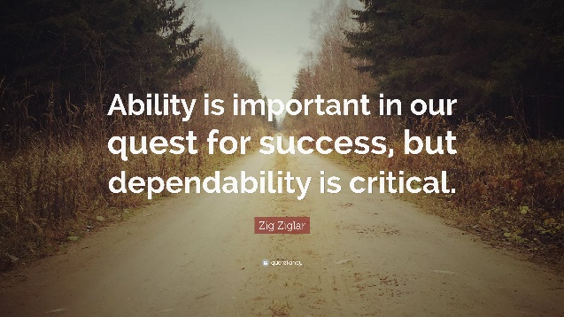

Image Source: quotefancy.com

**Dependability**

*Positive attributes.*

* (Name of employee) has remained one of our most

trustworthy team members.

* (Name of employee) is always very dependable in

every situation.

* (Name of employee) is always ready to do whatever

it takes to get the work done.

* (Name of employee) is well known for dependability

and readiness to work hard.

* (Name of employee) has been a faithful and trustworthy employee.
* (Name of employee) consistently demonstrates that they care about their job.
* (Name of employee) always performs functions routinely meeting or exceeding expectations.
* (Name of employee) can always be relied upon to finish tasks promptly.
* (Name of employee) is always ready to complete assignments no matter how much work is involved.
* (Name of employee) is willing to work overtime until the project is finished.
* (Name of employee) is the go-to person if the task must be completed by a given time.
* (Name of employee) is dependable and performs well each day.
* (Name of employee) shows faithful commitment to completing the job by consistently performing at or above expectations.
* (Name of employee) is known for being dependable and willing to do what it takes.
* (Name of employee) can be counted upon for steady performance.
* (Name of employee) consistently demonstrates solid performance in all aspects of work.
* (Name of employee) handles projects conscientiously from start to finish.

*Negative or improvement needed attributes.*

* (Name of employee) job results are unreliable and often need to be reviewed.
* (Name of employee) dependability and reliability can be improved upon.
* (Name of employee) does not always show a readiness to do what it takes to get the work done correctly.
* (Name of employee) often abandons work for others to finish.
* (Name of employee) has not shown a willingness to help other peers or team members with their work.
* (Name of employee) does not bother about managers’ and coworkers’ feedback.
* (Name of employee) productivity is not as good as his coworkers.
* (Name of employee) is very loyal but cannot be depended on.
* (Name of employee) demands reliability from others but not himself.
* (Name of employee) has energy, drive, and performance levels that are inconsistent and unpredictable.
* (Name of employee) makes promises they simply cannot or don’t keep.
* (Name of employee) guarantees that deadlines will be met but consistently misses them.



**Coaching and Training**

*Positive attributes*

* (Name of employee) accepts coaching in various job duties and

applies training to improve ability.

* (Name of employee) asks for more training when processes aren’t

clear or understood.

* (Name of employee) is willing to learn new processes.
* (Name of employee) is eager to learn new software and improve

efficiency.

* (Name of employee) is committed to continuing professional

Image Source: onthethreshold.com

development at a personal and team level.

* (Name of employee) is willing to learn new skills, techniques, and methods.
* (Name of employee) regularly shares learning experiences and knowledge with colleagues.
* (Name of employee) enjoys taking part in on-the-job training.
* (Name of employee) encourages all the team members to join in the necessary training sessions.
* (Name of employee) is able to learn concepts quickly and adopt them into their performance.
* (Name of employee) always finds opportunities to participate in specialized training sessions.

*Negative or improvement needed attributes*

* (Name of employee) could benefit from seeking more training in various tasks.
* (Name of employee) could benefit from asking more questions when unsure of expectations.
* (Name of employee) is reluctant to learn new processes and believes they are a hindrance.
* (Name of employee) could improve adaptability to learning new software and procedures.
* (Name of employee) shows a reluctance to participate in formal training programs or professional development opportunities.
* (Name of employee) fails to promote a team learning culture.
* (Name of employee) struggles to identify learning opportunities for team members.
* (Name of employee) lacks the initiative to proactively take on new tasks or projects.
* (Name of employee) should take part in more training opportunities and concentrate on them.
* (Name of employee) should prepare before coming to training sessions.
* (Name of employee) does not know how to apply the knowledge learned in training sessions into his performance.